Title: | Window Lifter  SW Component < XXXXXXX >

History
Issue status  (Index) | Maturity/Date  (draft/invalid/valid)  (dd-mmm-yyyy) | Author  Department | Check/Release  Department | Description
0.5 | Draft  22/06/2015 | Michele Balbi | Michele Balbi | Creation of the document and first formatting.
1 | 24/06/2015 | Michele Balbi |  | Definitions and Internal Breakdown.

Table of Contents
1 Purpose 4
2 Definitions and abbreviations 4
3 Realization constraints and targets 4
4 SW Conceptual design 4
5 SW Component internal breakdown 6
5.1 Functional Decomposition 6
5.2 Function <Type> <function name> (type par 1, .., type par n) 8
5.3 Function int main(void) 8
5.4 Function void Button_handler(void) 9
5.5 Function void Pinch_handler(void) 10

Purpose
This document has been created as a demonstration to the students of UdeG to how to create the detailed design from requirements.

This Design Specification Document aims to show the complete implementation for a Window Lifter Control simulation, including UP/DOWN motion with invalid button press and anti-pinch functionality.

Definitions and abbreviations
Definitions
Special Byte | Special byte received to change the baudrate 55h
T_UBYTE | unsigned char
LED_LEVEL_MIN | To hold the value of the GPIO pin that corresponds to the lowest LED to be turned on in the LED bar.
LED_LEVEL_MAX | To hold the value of the GPIO pin that corresponds to the highest LED to be turned on in the LED bar.
Abbreviations
Only SW Component specific abbreviations.
References
N° | Document name | Reference
1 | SW Architecture description
1 | Requirements document
2 | SW Architecture description
3 | HW Architecture description
4 | Header file with Continental typedefs

Realization constraints and targets

An overview of which are the goals that must be achieved with this functionalities.

The SW must be able to control de 10-led bar to simulate a window lifter.
It shall detect invalid inputs and ignore them.
It shall be able to detect possible pinch situations and avoid them according to the behavior specified in the requirements document.

SW Conceptual design
To make a conceptual design identify the product functions and the programs parts needed to produce them.
- Identifie all relevant parts in a system or sub-system.
- Define which parts are inside & outside the system boundary
- Define de interfaces between these parts, but also interfaces with neighboring systems and environment.

External HW
Switches / push buttons
LED bar
Up / Down LED indicators

GPIO module

Interrupts module
MCU

MCU core

SW Component internal breakdown
For complex SW Components, the designer may define SW Subcomponents. Please consider also the work step "Deal with complexity" provided by the method for Detailed SW Design.
Note: SW Subcomponents are synonymous with the previous used term "Module"
Mapping to the file structure:
- Non complex SW Components should be represented by one object file.
- For complex SW Components each SW Subcomponent should be represented by one object file.
<Subcomponent decomposition if applicable>

Functional Decomposition
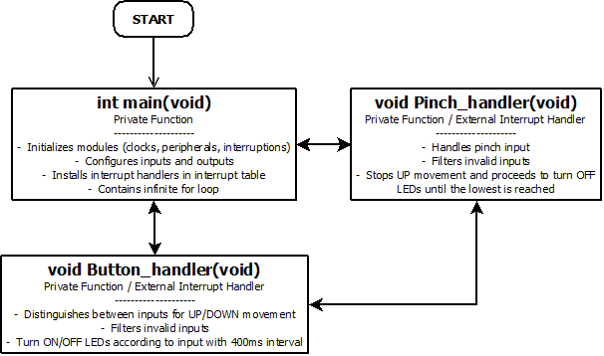
Overview of functions and their dependencies shown by a Static Function Tree
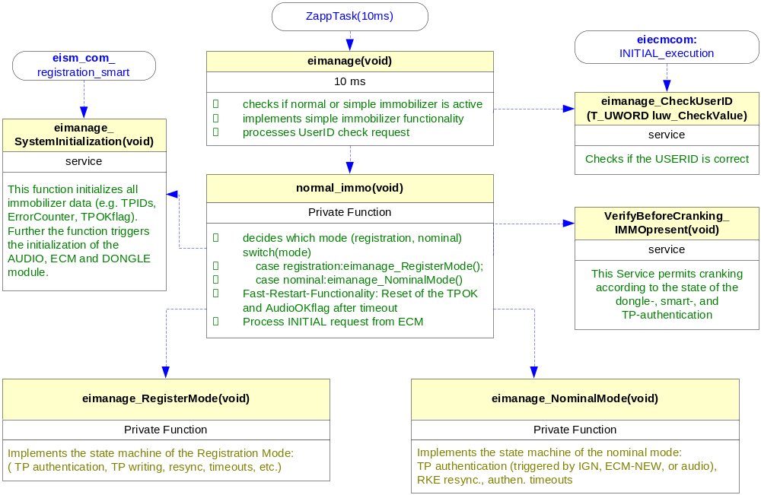
Function Description and Dynamic Behavior
Provide detailed static and dynamic description of all functions of the SW Component.
Functions which are defined in other SW Components shall only be referenced in the external interface description!
The signature description shall be done inside the function header in the source code.
For each function, the following section should be copied

Function <Type> <function name> (type par 1, .., type par n)

Description | Brief description of the function behavior and useful remarks
Parameter 1  <input| output| inout> | Give an explanation if the parameter shall be checked by the user, or if a check is implemented in the function here
Parameter 2..n
Return Value
Precondition | e.g. Function can only be called in a certain state, SW component is initialized  Relation between input parameters where applicable (Input for Module Test)
Post condition | e.g. specific State change e.g. car is locked, EEPROM Values written,  Relation between output parameters where applicable
Error Conditions

Dynamic Behavior
State Chart¹, Flow Chart¹
¹ Preferred
In this document, the dynamic behavior shall be designed on an abstract level showing the principle workflow of a function. Do not show the detailed implementation to ensure that the design description can be maintained with a reasonable effort. The target is not to show the complete detailed implementation 1:1.
The detailed design shall reflect in detail what a function is doing from a black box view. The internal details are useful on an abstract, but not very detailed level.
If the function is not complex a short textual description might be sufficient and a graphical description is not needed.
Symbol and function names shall be self explaining.
The link to the implementation may be provided by using the same names as in the design or by a comment showing the full name followed by the declaration showing the implementation.

Function int main(void)
Description | The main function prepares the MCU to control the led bar. It initializes the system and peripheral clocks, GPIO registers, and it configures the interruptions. It loops the MCU with an infinite for, so every interaction with the MCU shall be done using interruptions.
Return Value | Standard
Precondition | MCU power-on reset (?)
Post condition | -
Error Conditions | -

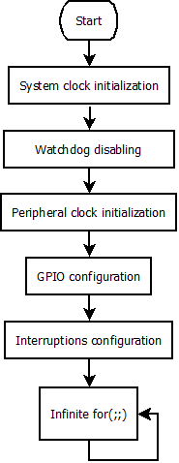
Dynamic Behavior

Function void Button_handler(void)
Description | This function handles the external interruptions caused by the push buttons for the UP and DOWN movement of the window. It implements the filter to ignore invalid inputs (a 10ms-delay).  It distinguishes the movement type (automatic/manual), depending on the time the push button was pressed and sets the appropriate value in the dedicated variable (re_move) so the according operations (turning LEDs in the LED bar on/off, turning on/off movement-type LED indicators) are done.
Return Value | void
Precondition | External interruption caused by a push button.
Post condition | LED bar illumination change.
Error Conditions | -

Dynamic Behavior

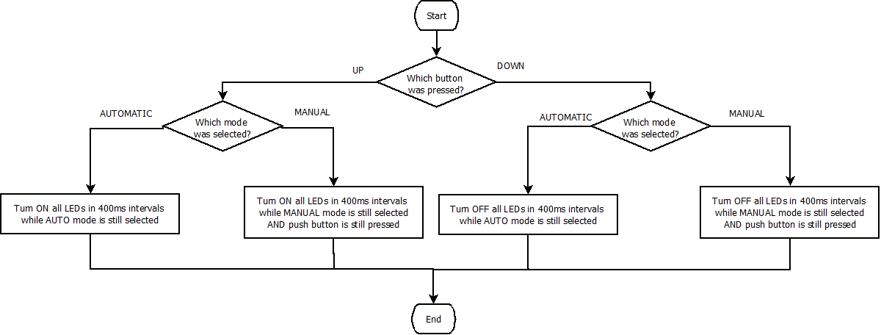

Function void Pinch_handler(void)
Description | This function handles the external interruption caused by the pinch detection signal. It implements the filter to ignore invalid inputs (a 10ms-delay).  It checks for any active up movement to stop it and turn off all LEDs in the LED bar. Then it blocks any signal detection for 5 seconds, as per requirement.
Return Value | void
Precondition | External interruption caused by the pinch signal.
Post condition | LED bar illumination change (turn LEDs off),  re_move = DISABLED
Error Conditions | -
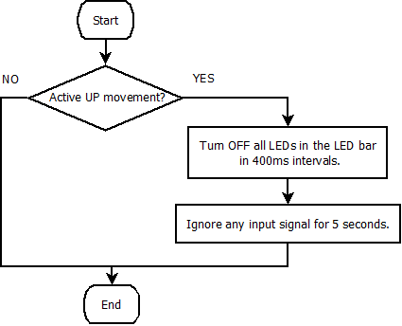
Dynamic Behavior

